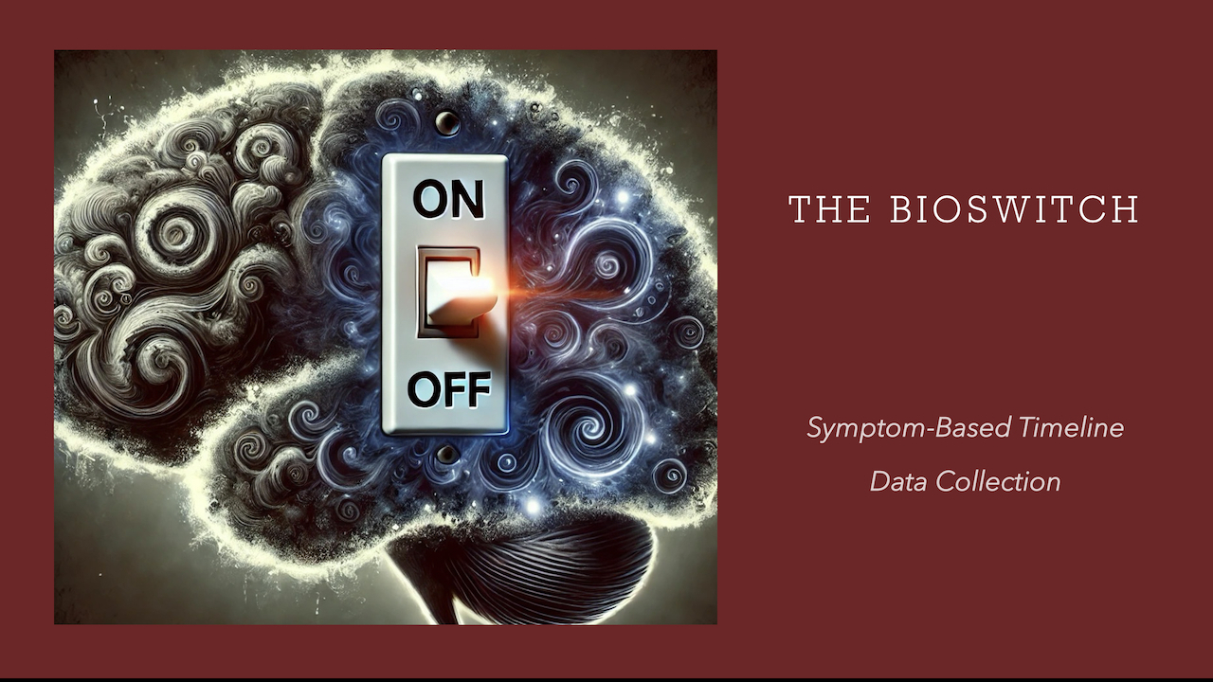

Name:
Condition:

- Physical Symptoms
- Specific Body Part
- Triggering Conflict (Life Cause)
- Biological Purpose
- Conflict Active, Repair Phase, or Repair Crisis
- Timeline (prepare a detailed timeline of every time you experienced the symptom back to the first experience) | See table below
- Conflict Content
- Tracks/Reminders

Symptom-Based Timeline Back To When You “First” Experienced The Symptom (only one symptom per timeline)

Date | Life Event | Symptom Response | Intensity 1-10

Oct 12, 2015 | E.g., I resolved a conflict of not pursuing my passion and following my life’s path. | I had very painful lumbar spine pain with shooting pains down my right leg. | 9

